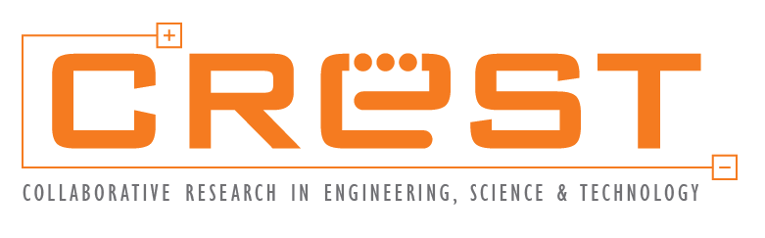
PARTICIPANT NAMELIST

UPSKILLING GRANT FOR INDUSTRY CURRENT WORKFORCE

Pdf format of this form must be submitted to CREST at traininggrant@crest.my
[Incomplete details will affect the claim process]

SECTION 1 : PARTICIPANT DETAILS
Company Name
Letter of Award (LoA)
Reference Number
Participant Details
No. | Full Name (as per NRIC) | NRIC | Position Title | Type of Employment | Gender | Citizenship
 |  |  | i.e. Maintenance Technician | i.e. Full time/ Contract 12 months | M/F | Malaysian

SECTION 2 : DECLARATION BY GRANT RECEIPIENT
We hereby declare that:

- All information stated here are true, accurate and in agreement with the terms and conditions of this program. CREST has the right to reject or to cancel the offer without prior notice if there is any inaccurate information given.

Applicant Signature | Acknowledgement by Company Management  (Example: CEO, Managing Director, Head of HR)
Name:  Designation:  Date: | Name:  Designation:  Date:
Company Stamp:

DOCUMENT CHECKLIST FOR PARTICIPANT NAME LIST
Documents | Please tick on the relevant sections
Copy of Identity Card (IC) for all participants (pdf format)

OR

A letter from HR (on company letterhead, pdf format) to state the participants
are employees of the company and based on HR’s record, the participants’ full
name and IC number are as below:

- Full Name (as per IC)
- Identity Card Number (IC Number)

Please address the letter to:
Collaborative Research in Engineering, Science and Technology Center (CREST)
sains@usm
Block C, Ground Floor
10 Persiaran Bukit Jambul
11900 Bayan Lepas
Pulau Pinang
Attention: Chief Executive Officer

