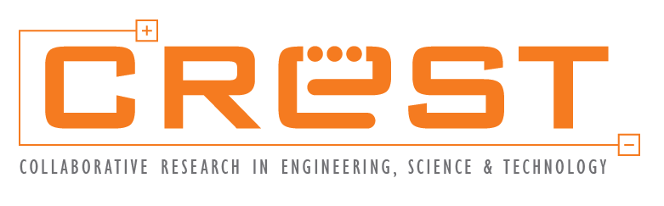
CHANGE REQUEST FORM
FOR CURRICULUM DEVELOPMENT

GRANT TO UPGRADE TECHNICAL CAPABILITIES OF EDUCATIONAL INSTITUTIONS

Pdf format of this form must be submitted to CREST at traininggrant@crest.my
[Incomplete form will not be processed]

SECTION 1 : GRANT RECEIPIENT INFORMATION
Letter of Award (Program LoA) Reference Number
Education Institution Name
Business Address
Contact Person Details (education institution representative that can answer any enquiries on the claim details)
Full Name
Designation
Contact Number | office phone number & mobile number
Email

SECTION 2 : CHANGE REQUEST (please complete the relevant sections. For sections which are not relevant, please indicate “not applicable”)
Curriculum Development Period (Please ensure the new curriculum development period does not exceed 31st December 2025. Attach the new Appendix 2 Project Timeline from the Grant Agreement to this form)
Previous Activity Date | Start Date dd/mm/yyyy to End Date (dd/mm/yyyy)
New Activity Date | Start Date dd/mm/yyyy to End Date (dd/mm/yyyy)
Curriculum Embedment Period (Please ensure the new curriculum embedment initiation period does not exceed 31st December 2025. Attach the new Appendix 2 Project Timeline from the Grant Agreement to this form)
Previous Activity Date | Start Date dd/mm/yyyy to End Date (dd/mm/yyyy)
New Activity Date | Start Date dd/mm/yyyy to End Date (dd/mm/yyyy)
Completion of 1 training program to be conducted by the Institution based on the Curriculum for students of the Institution or current workforce using the new Curriculum
(Please ensure that the delivery of the training program is completed no later than 31st December 2025. Any extension beyond this date will require written justification and prior approval from CREST. Attach the new Appendix 2 Project Timeline from the Grant Agreement to this form)
Previous Activity Date | Start Date dd/mm/yyyy to End Date (dd/mm/yyyy)
New Activity Date | Start Date dd/mm/yyyy to End Date (dd/mm/yyyy)
Other Changes
Justification for Change (please state the reason for change request)

SECTION 3 : DECLARATION BY APPLICANT
We hereby declare that:

- All information stated here are true, accurate and in agreement with the terms and conditions of this program. CREST has the right to reject the change request without prior notice if there is any inaccurate information given.

- No corrupt practices, unlawful and/or illegal activities have been committed during submission of this request.

Applicant Signature | Acknowledgement by Education Institution’s Management  (Example: CEO, Managing Director, Head of HR)
Name:  Designation:  Date: | Name:  Designation:  Date:
Education Institution’s Organization Stamp:

Terms & Conditions:
- Confidentiality: All change requests submitted will be treated in strict confidence.
- Right to Accept or Reject: CREST reserves the right to accept or reject any or all change requests received at its sole and absolute discretion. The decision of CREST shall be final and binding on the applicant and may not be challenged.
- Submission Deadline: Change requests submitted after 30 days from the expiry date of the Grant Agreement will not be entertained.
- Supporting Documentation: All change requests must be accompanied by relevant supporting documentation justifying the need for the change. Incomplete requests will not be considered. CREST reserves the right to request for additional supporting documentation to support the change request.
- Compliance with Terms and Conditions: All changes requested must comply with and will be subject to (a) the terms and conditions in this Change Request Form; (b) the standards, guidelines, administrative requirements, protocols, processes, rules, and regulations prescribed by CREST for the Grant and the Program, as may be set out under the “Introduction”, “Grant Focus Area”, “Grant Guideline”, “Reference Documents”, and “Terms & Conditions” tabs on CREST’s website and any other documentation for the Program made available by CREST in respect of the Program, which the Education Institution is required to comply with; (c) the General Terms and Conditions for the Program as displayed on CREST’s website and/or any platform(s) utilised by CREST for administration of the Grant and Program; and (d) the terms and conditions as stipulated in CREST’s application form for the Program, available on the CREST Grant Management Platform in respect of the Program. Any change request found to be in violation of the said terms and conditions may be rejected.
- No Impact on Program Outcomes: Any approved change request must not adversely impact the intended outcomes of the Program as outlined in the original application, Grant Agreement and Program LoA.

SECTION 4 : APPROVAL BY CREST
Remarks:

Recommended By | Signature
Name:
Designation:
Date:
Verified By | Signature
Name:
Designation:
Date:
Approved By | Signature
Name:
Designation:
Date:

